1. What is Boolean? Write down 3 different expression that results a Boolean type (i.e. 5 == 6)

*A Boolean value is either true or false. It is named after the British mathematician, George Boole, who first formulated Boolean algebra — some rules for reasoning about and combining these values. This is the basis of all modern computer logic.

Ex:

>>> 9 == (3 * 3)

True

>>> 1 == 6

False

>>> j = "pri"

>>> j + "nt" == "print"

True

1. What is a flow chart? Draw flow chart for the following code snippet: (you can draw on a paper, take a picture of it)

* A **flowchart** is a type of diagram that represents an algorithm, workflow or process. The **flowchart** shows the steps as boxes of various kinds, and their order by connecting the boxes with arrows. Flowcharts are used in analyzing, designing, documenting or managing a process or program in various fields.

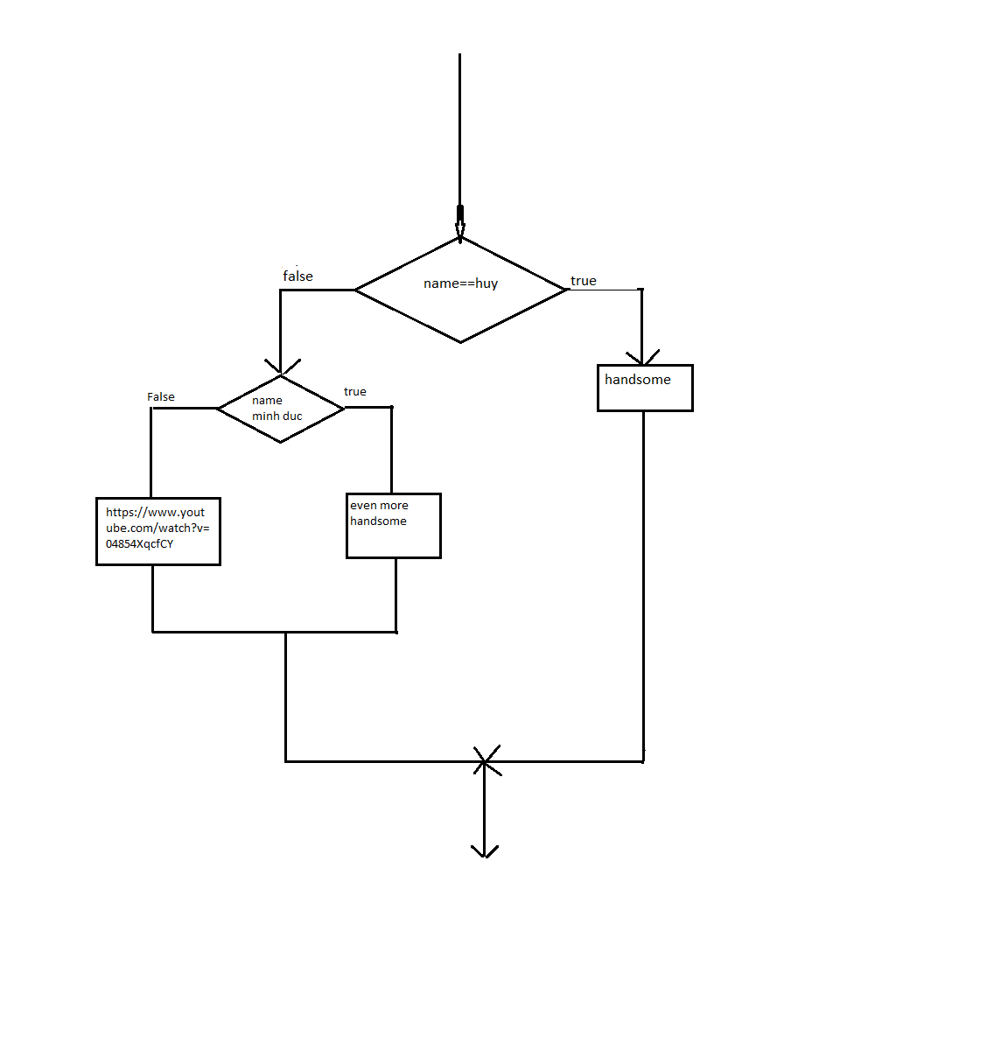

1. What is nested conditionals? Write a piece of code that uses nested conditionals

*Nested conditionals. One conditional can also be nested within another. The outer conditional contains two branches. The second branch (the else from the outer) contains another ifstatement, which has two branches of its own. Those two branches could contain conditional statements as well.

Ex:

if 0 < x<10:

print("x is a positive single digit.")

else:

print(“x is a positive digit which is equal or more than 10”)